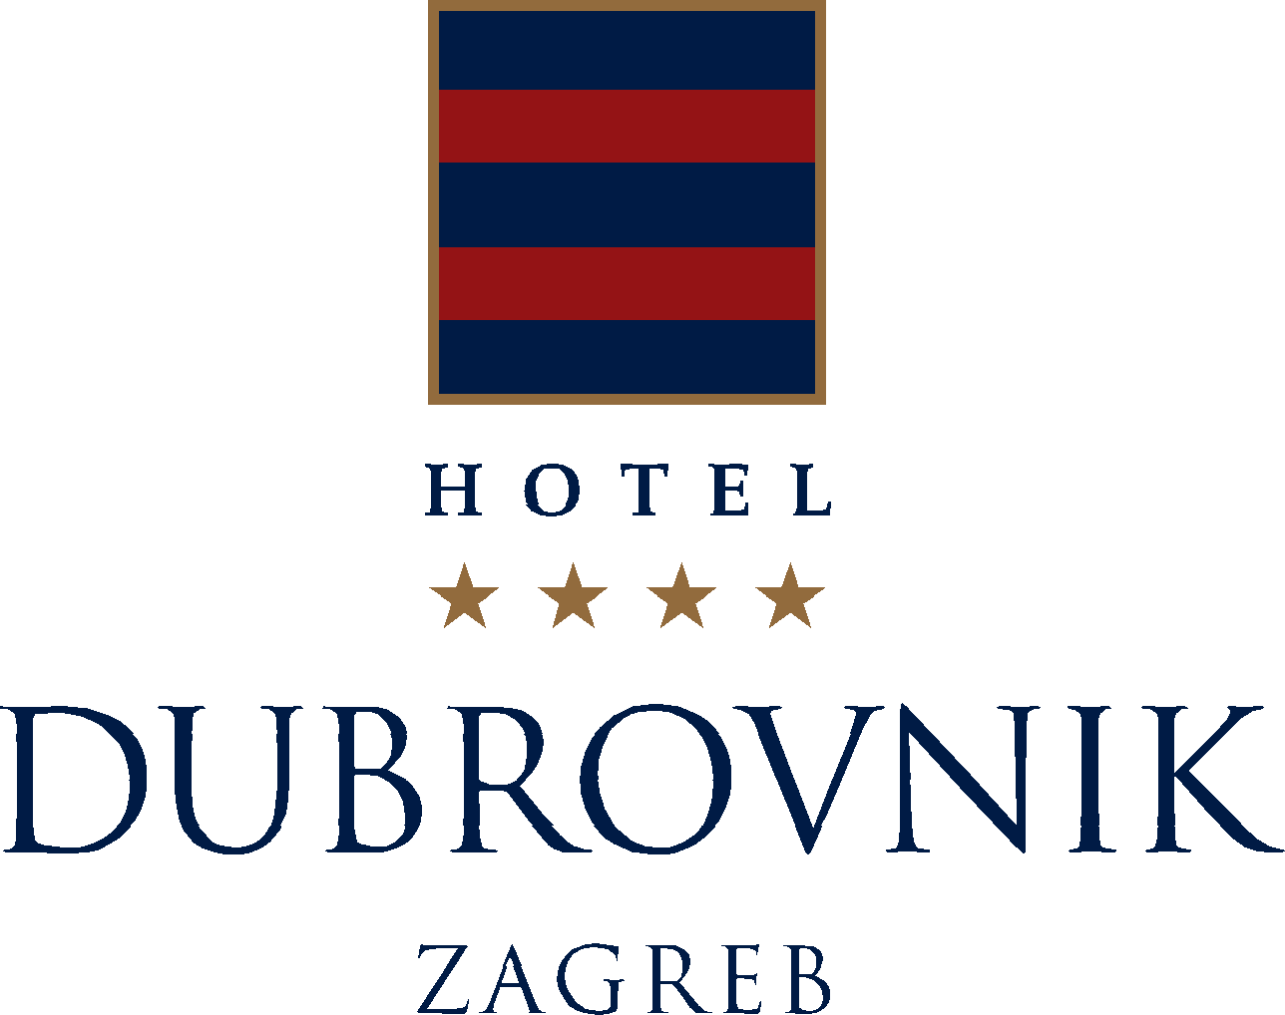

SPECIAL OFFER FOR ACCOMODATION

20th Ramiro and Zoran Bujas’days

07 April - 09April

Hotel Dubrovnik, your host in Zagreb with its tradition since 1929, is located in the very center of Zagreb at Ban Jelacic Square, is surrounded by the most important government and economic institutions, cultural buildings and monuments and the main pedestrian and shopping area, lively cafés, bars and parks. The hotel is the best choice for business travelers who are looking to please their tourist spirit, as well as for organization of different conferences, meetings and events.

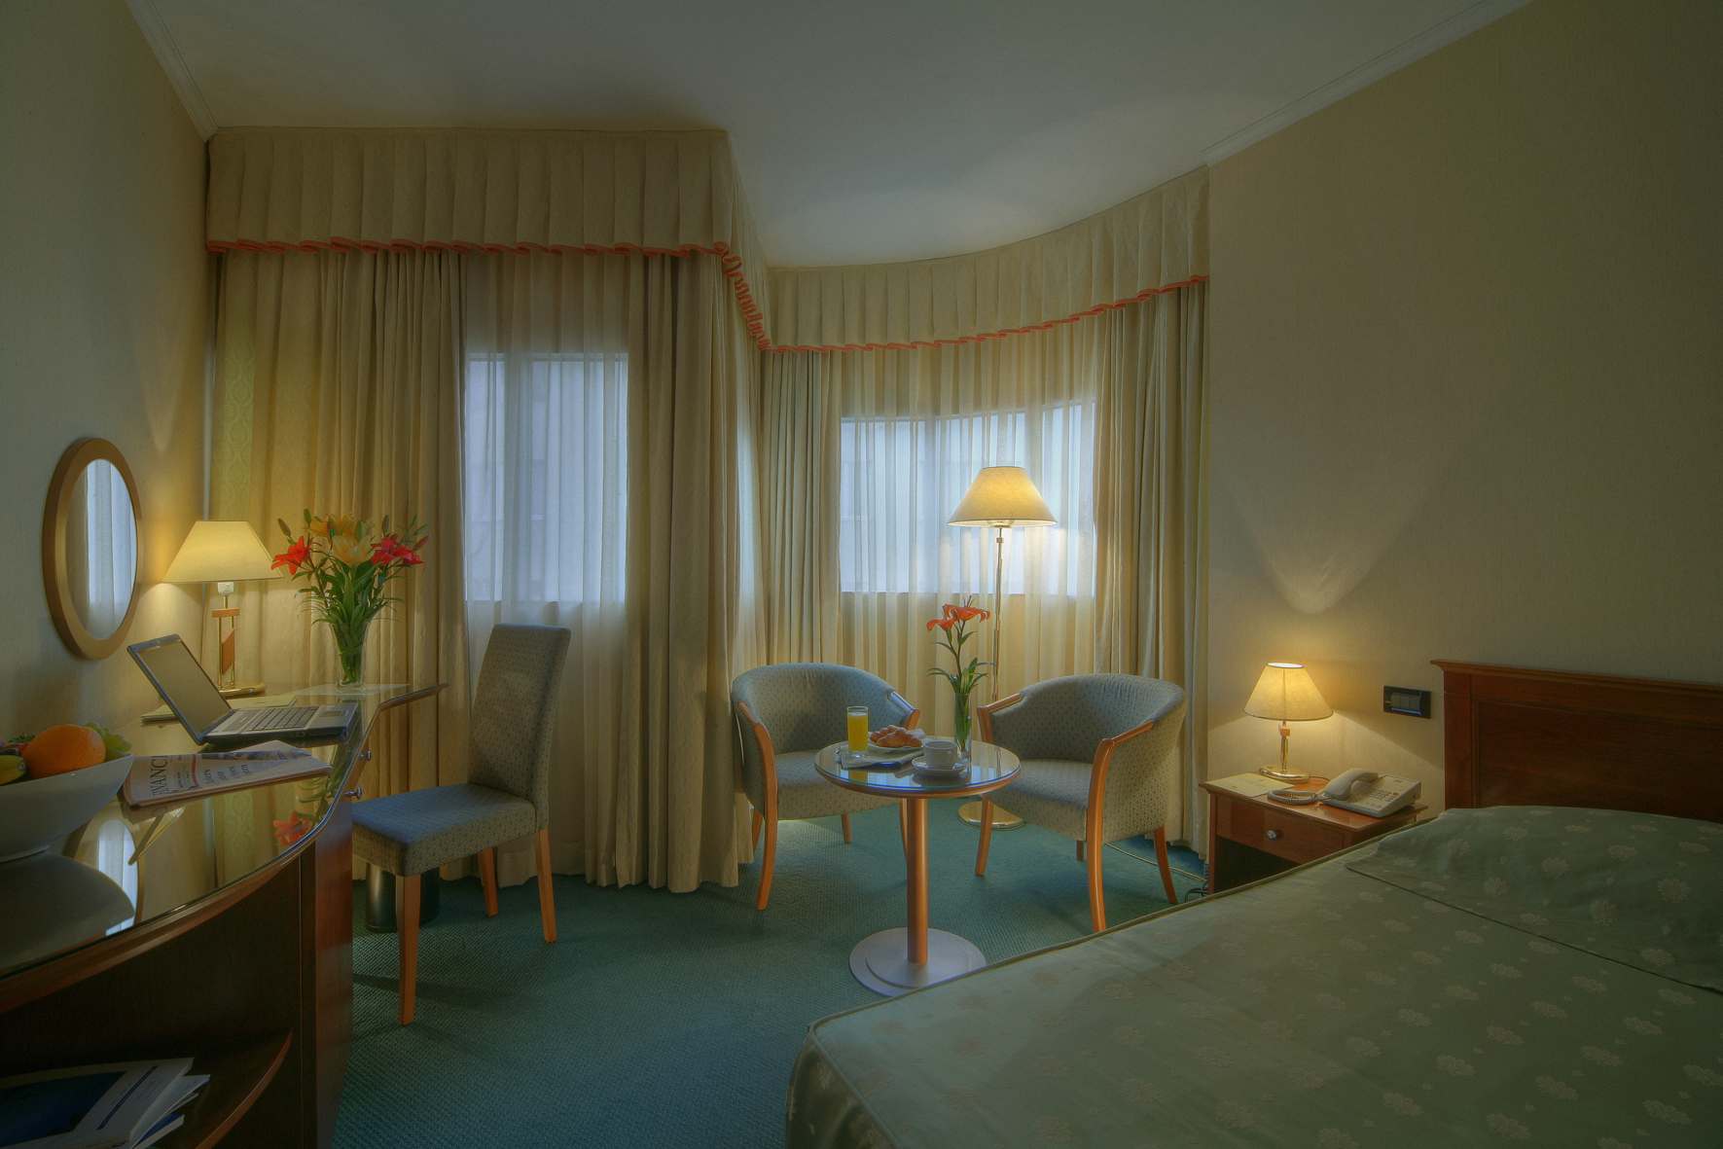
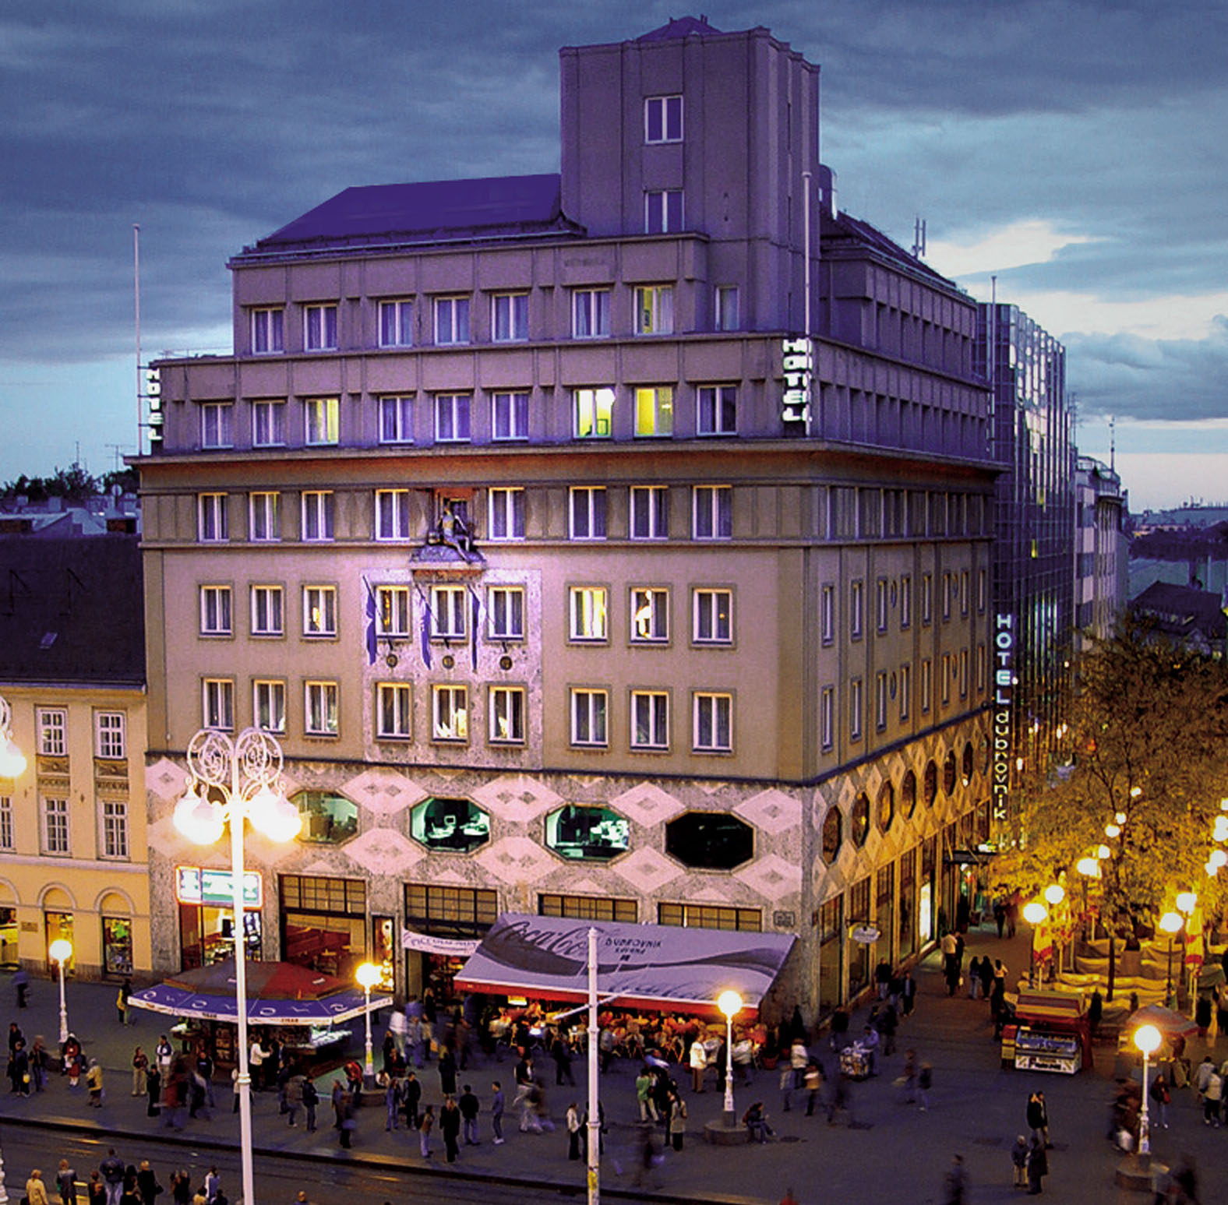

Hotel Dubrovnik is offering special prices for the accommodation:

Single room at special price 550 kn cca 76 € per room per night
(standard price 980 kn cca 135 eur)

City tax 7 kn cca 1 € per person per day

VAT and breakfast are included in the price

While making the reservation please refer to 20th Ramiro and Zoran Bujas’days

Reservation contacts :+ 385 1 4863 502, fax: + 385 1 4863 507;
e-mail: iperkovic@hotel-dubrovnik.hr

Hotel Dubrovnik d.d. • Gajeva 1, 10000 Zagreb, Hrvatska
www.hotel-dubrovnik.hr

