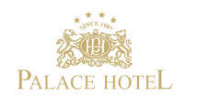

The Palace Hotel Zagreb, situated in the centre of the city in a palace immediately next to the old city park, opened its doors in 1907 as the first professionally organised hotel in Zagreb. The hotel underwent renovations in order to be modernised and follow contemporary hotel management trends. Today it merges the comfort of modern lifestyle with a warm retro-chic atmosphere created by its antique-style furniture and its modernist interior.

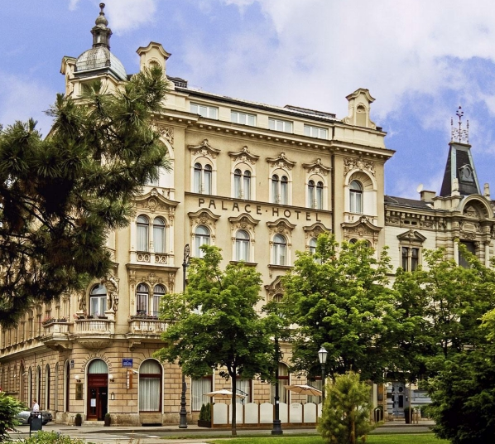

PROPOSAL
From: Palace Hotel Zagreb
To: University of Zagreb Fac.of Humanities and Soc. Sciences
City: Zagreb
Event: 20th Ramiro and Zoran Bujas' Days
Country: Croatia

SMJEŠTAJ:

Arrival date: 07.04.2011.
Departure date: 09.04.2011.

No. of rooms: TBA

Room Type |  | Room Rate
Comfort soba | Single  Double | 80 EUR  95 EUR

The rates above are per room per night are inclusive of VAT and buffet breakfast. Additional benefits for all our guests is free wireless Internet and service of Business center. Supplement for city tax is 7,00 KN per person per day.

The hotel's check in time is from 15:00 hours. Room assignment prior to this time is subject to availability. Check-out time is at 12:00 hours.

Hotel will provide 8% of commission on net rates (without VAT).

TERMS & CONDITIONS:

This offer is valid for the full extent of services outlined above.

Unless suitable credit terms are established with the hotel, advance payment will be required and we reserve the right only to provide services that air paid for in advance.

VAT is included in all rates and rates quoted in Euros, other than for guest room acommodation, are indicative only and subject to currency fluctuations.

Again, thank you so much for considering Palace Hotel Zagreb and we look forward to welcoming you and your guests to the hotel.

Kind regards,

Sandra Rimarčuk

Sales Representative

